**IFT 466 Advanced Computer Networks**

**Lab 35   
  
Demarcation Point**

After you complete each step, put a ‘√’ or ‘x’ in the completed box

**Be wary of the final step….you will need a camera!**

There are many technologies that are implemented to connect to the customer.

The point where an ISP’s network ends and a customer’s network starts is called the Demarcation Point or Network Interface Device - NID.   
  
ISPs own their systems up to a specific point, and it’s important to understand where the liability ends for both the ISP and for the customer.

****For home users this point has become blurred in recent years with the “rented” modems and routers. These devices are clearly owned by the ISP, but the cable in the wall that connects to the demarcation point belong to the User. These devices tend to contain surge suppression to protect ISP wiring and most of the time allows for disconnection of wiring to help you aid in troubleshooting.

✓

Typically, outside of residential buildings next to the electrical service you’ll find services boxes that look like the below pictures. In short these are typical in residential and non-custom commercial connections.

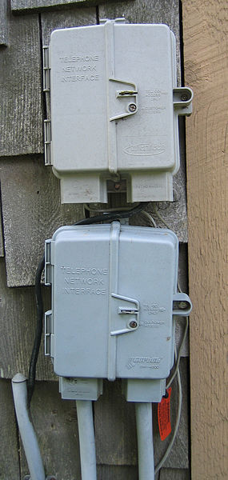

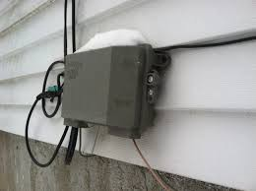



✓

In shared locations like apartments or strip malls, it’s not uncommon for there to be a shared communications room for a building. The Demarcation point can be found in these rooms as well.

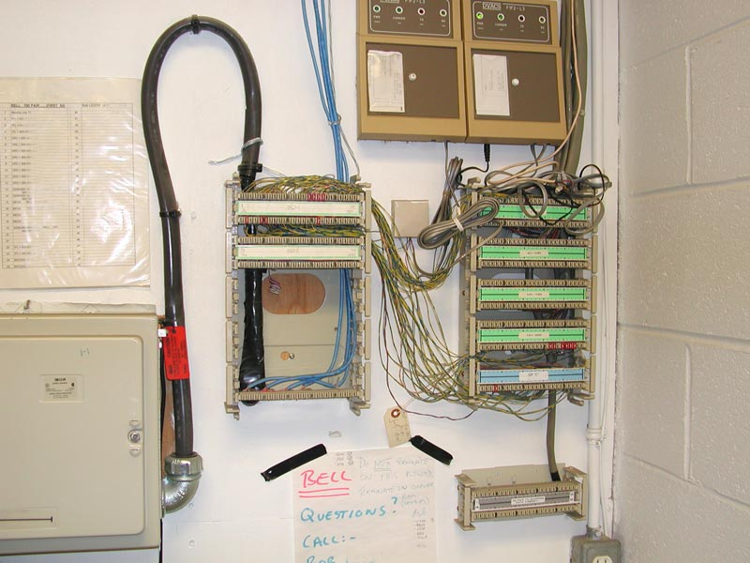

 ✓

**Digital Subscriber Line (DSL)**

Technology that runs on POTS (Plain Old Telephone System).

Cable is typically strung up on telephone phones or in underground conduit  
  
Will typically present be terminated in a box where the ISP connection comes from the left and customer side comes out the right.   
  
ISPs liability exists right up to the punch-down connector that connects to the customers house wiring.

Each outlet inside the house has its own punch-down connection in this configuration.

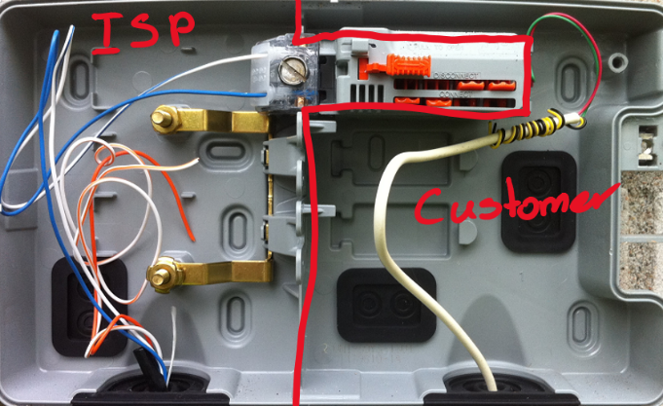



✓

**Cable**

Less complicated in wiring than DSL cabling  
  
Cable based ISP’s control ends right at the Male to Male connector that is mounted in the box to furnish the customer where the customer can use a splitter to feed into all their outlets.

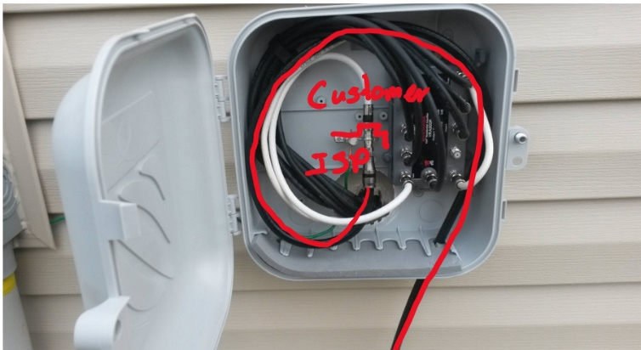



✓

**Fiber**

Fiber is even simpler still.   
  
Since Fiber doesn’t share its data medium with other technology like DSL and Cable, its purpose built for data connectivity.   
  
Typically, inside the service box you will have a couple of fibers brought in and mounted for you to connect to with your own wiring.   
  
Although in residential configurations ISPs will also have media converters to convert the fiber media to easier to connect RJ45 connection and sometimes convert to RJ11 or RG6 connectivity.

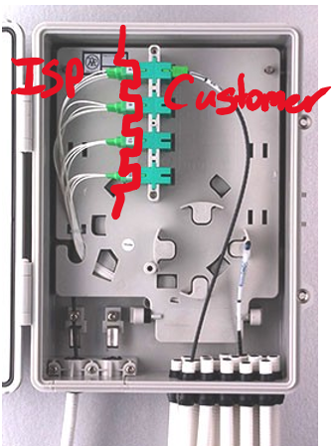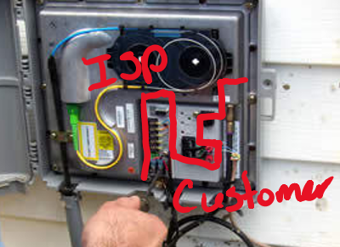



✓

Your task is to take a selfie with a demarcation point at your house, apartment or at your work.

You must also specify if the demarcation point is DSL, Cable or Fiber.

Put your selfie inside this box

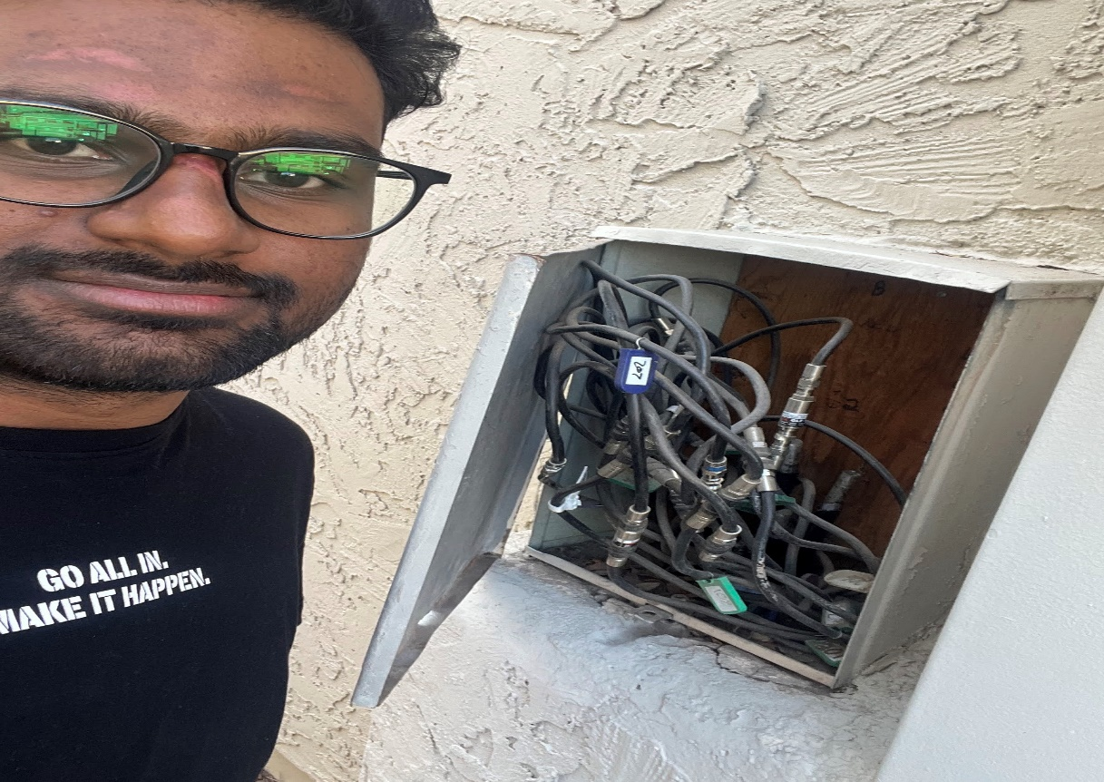

Specify the type of demarcation point in your selfie?

**Coaxial Cable**